Algebra 1: Unit 4, Lesson 8

- The graph of function $f(x)$, is shown.
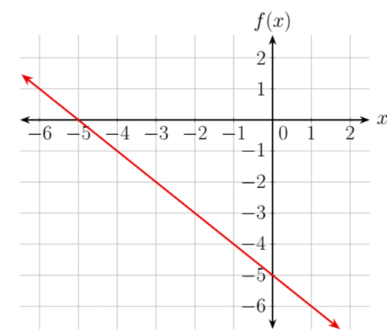
What is the slope of $f(x)$?
-1

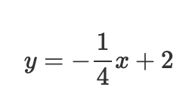
- A linear function is shown.

What is the $x-$ intercept of the function?
8

- The graph of function $f(x)$, is shown.
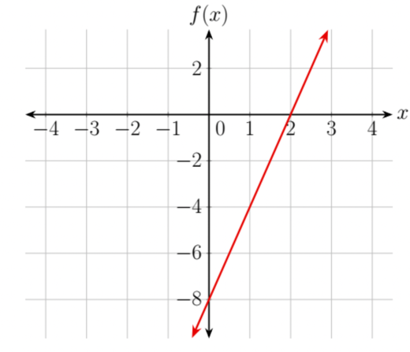
Complete the statement.
As the $x-$values increase, the $y-$ values _____________________.
Increase

